STEPS TO CLEAR FAULT STATE OF GOOGLE FIREBASE
- Type VNC Viewer on search bar in windows and hit Enter.
- The following screen will popup. 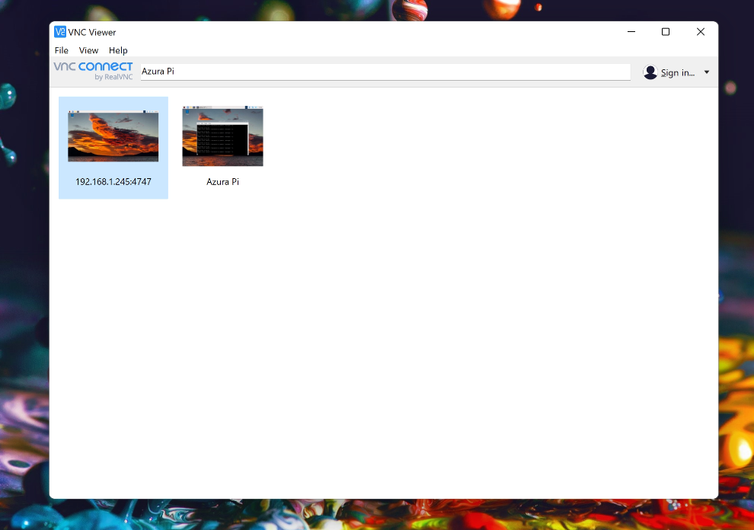

- Double click on Azura Pi to remotely enter the Raspberry Pi located at Azura community
- Click anywhere on the black window inside Azura Pi and press Ctrl+C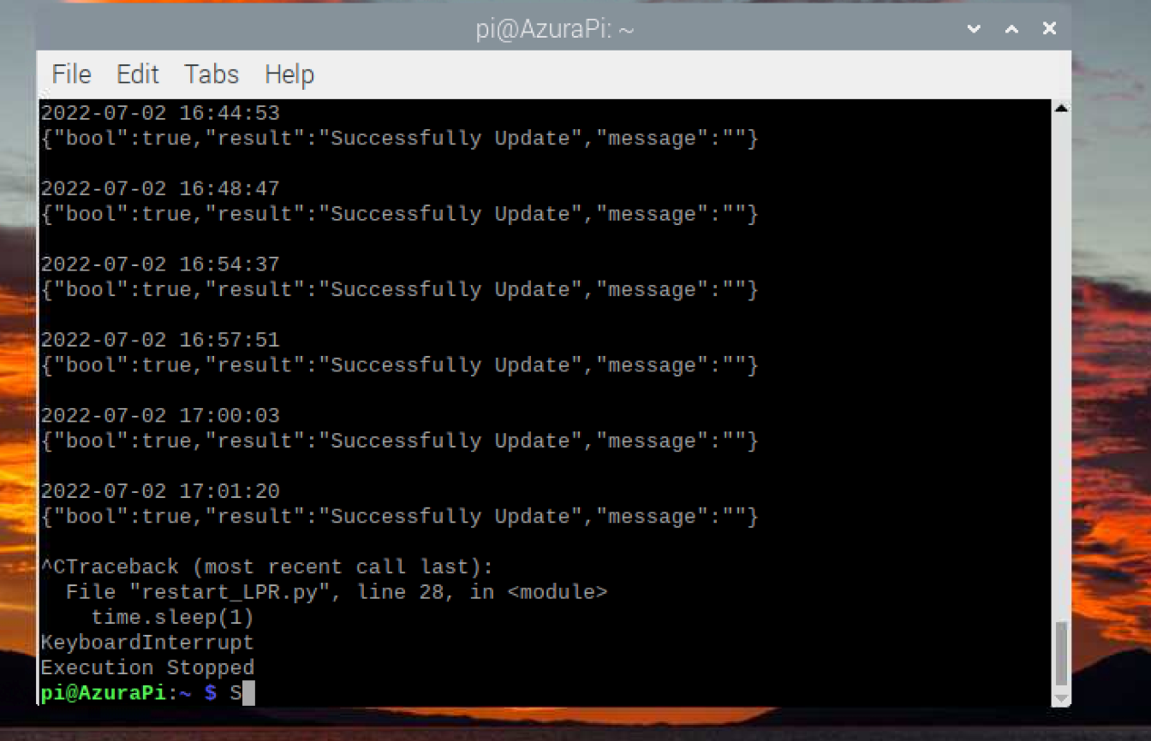
- After Execution Stopped is printed on the screen, press the Upside Arrow on the keyboard or manually type in the command sudo python restart_LPR.py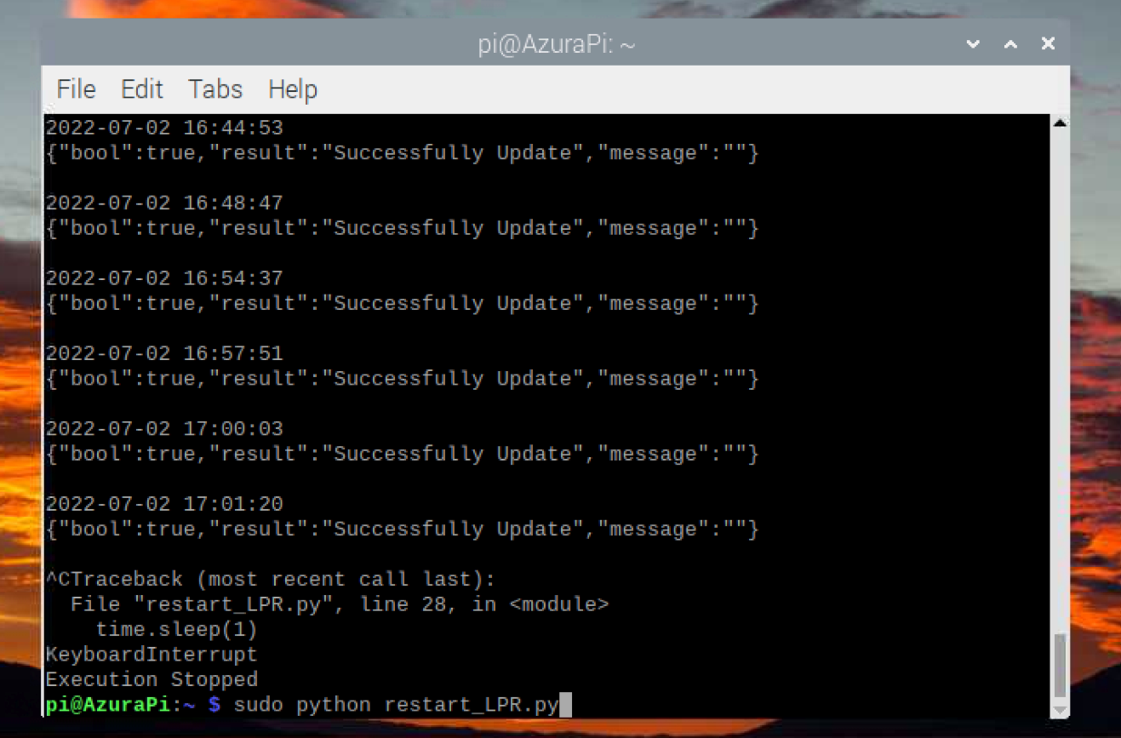

- Hit Enter and retest the working of the camera. This will bring the Firebase out of hault state

